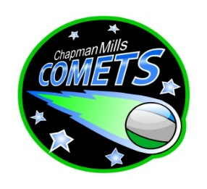
Chapman Mills Public School

School Council Agenda for February 22, 2024
6:30pm – 8:00pm
Chapman Mills Public School – Staffroom

Item | Agenda topic | Presenter | Time (min)
 | Welcome  - Land Acknowledgement  - Review Agenda  - Approve minutes of previous Council Meeting  - Meeting conduct | Trish Taylor | 10
 | Principal’s Update | Paul McAnany/ Bethany Pye | 15
 | PRO grant topic discussion  MOTION – To use the PRO grant funds ($750) to host the webinar on Faith and 2SLGBTQI | Trish Taylor | 10
 | Teachers’ Update | Cynthia Roberts/ Andrea Hardy | 10
 | Finance Update  - Discussion on use of available funds | Will McCarthy /  Trish Taylor | 10
 | Communications Update | Melina Larizza | 5
 | Fundraising/Events Update  - Magic Show – February 23 at 6:30pm  - Future proposed activities:  - May: Jump Rope for Heart Fundraiser  - June: Kinder night | Mary Melady | 10
 | Hot Lunch Program Update  - Orders are open until March Break | Nivedita Muthukumarasamy | 5
 | Year-end Event Update | Melina Larizza/  Nima Orazani/ Bryan Brunet/ Manosila Yoganathan | 5
 | Other  - Ottawa South United soccer club community outreach  - Constitution sub-committee  - MOTION – to change to date of the next Council meeting from Monday April 15 to Thursday April 25 due to conflicts for the Chair and Principal | Laura St. Cyr  Trish Taylor | 5
 | Round Table / Q&A | All | 5

